MINISTRY OF SCIENCE AND EDUCATION NATIONAL TECHNICAL UNIVERSITY “KHARKIV POLYTECHNIC INSTITUTE”

DEPARTMENT OF SOFTWARE ENGINEERING AND MANAGEMENT INFORMATION TECHNOLOGIES

Report from lab#2

Discipline “Software Architecture ”

Executed by: Student of group 1.КН201.8ei1

CHUKWU IRELE AMORIN

Checked by:

Prof. Khtasko

Task : USE CASE

Description : Flight ticket booking and payment use case

Customer goes to the flight booking website or the Flight booking office , Customer ask for available tickets . The system or the official shows the customer the available tickets .The user either accept the flight offer or rejects it ,if the user accept the offer then he/she pays for the flight .

Use case:

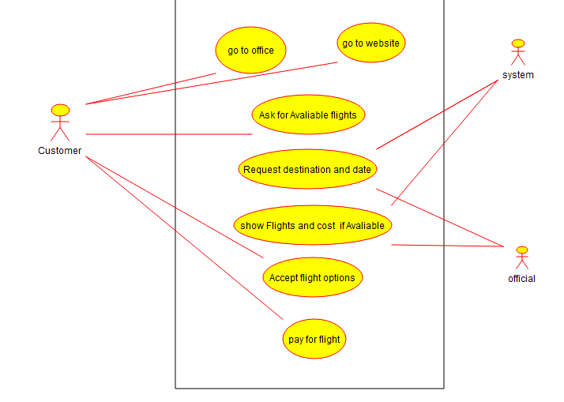

|  |  |
| --- | --- |
| Use-case | Flight ticket booking and payment |
| Actors | customer , Booking System , booking official |
| Purpose | Booking and paying for a flight |
| Short  Description | The customer books a flight |
| Type | Basic Include |
| Links to other  Uses |  |

The main section of the scenario of the use of the " Flight ticket booking and payment use case”

Section Typical course of events in the scenario of the implementation of the "" Flight ticket booking and payment use case" use-case

Use-case: Customer goes to Office

|  |  |
| --- | --- |
| Acting Actors | System Response |
| 1.Customer goes to office  4a. customer is not a new customer  4b. customer is a new customer  Exception 1: Office is closed | 2.Office receive customer    3. office agent ask customer if he /she is regular customer or a new customer  5a. the office collects customer identification number and confirms  5b.office agent registers new client and create customer identification number and create a password.  6. office agent ask for all customer’s flight preference |

Use-case:Customer goes to the website

|  |  |
| --- | --- |
| Acting Actors | System Response |
| 7.Customer goes to website  10a. customer choses to login  10b.customer choses to register  Exception 2: website is down | 8.website opens on customers device  9.website ask user to login or register  11a.website ask for customer identification number and password to login  11b.website creates a new account with new identification number and allows customer to create new password  12.user add all his/her flight preferences |

Use-Case: Customer ask for Available flights

|  |  |
| --- | --- |
| Acting Actors | System Response |
| 13.Customer Ask for Available Flights  16. customer confirm preference or edit existing preference and submit for search  Exception 4. No planes are flying | 14.System receive request  15. load customer stored preferences and ask customer to confirm the preference  Exception 3. Preferences fail to load  17. system load current preference and call web service for searching |

Use-Case: destination and date

|  |  |
| --- | --- |
| System Response | Acting Actors |
| 18. System or official ask for Destination flight.  Exception 5. Wrong destination  20. System ask for date of flight :  22. System ask for number of passengers  24. system ask if tickets are one way or return tickets | 19. Customer provide Destination of flight.  21. Customer provides flight date  Exception 6. Wrong date  23. Customer provide number of passengers  Exception 7. Invalid number of passengers.  25.custumer choses type of tickets |

Use-Case: Flights and cost available

|  |  |
| --- | --- |
| System Response | Acting Actors |
| 26.Sytem accepts all search parameters  27. System call search WebService and pass parameters.  28. Webservice search all flight companies with available airlines with condition of customer preference  Exception 8. WebService returns an error  29.system receive response from WebService  Exception 9. No flights | 30. all available flights are displayed to the user |

Use-Case: Acceptance

|  |  |
| --- | --- |
| Acting Actors | System Response |
| 31. Customer consider all available flights  32.customer choses an offer  33. customer ask for a discount  35.customer accept offer and ask for discount  Exception 10 . error in drawing up invoice | 34.system grant discount if available  36. System draw an invoice for the customer. |

Use-Case: Payment

|  |  |
| --- | --- |
| Acting Actors | System Response |
| 37.Customer choses to pay invoice    39. Customer choses a method and provides the medium for payment  41. customer provides security pass for processing payment  Exception 12. Invalid security pass  44.customer receive flight ticket ☺ | 38. System ask Customer which method of payment user wants to use to pay.  40. system accept payment medium and tries to process the payment  Exception 11. Invalid payment medium.  42. System processes the payment.  Exception 12.insufficient funds  43.system issue a ticket |